07 SEMANTICS
HOW VS WHAT TO COMMUNICATE
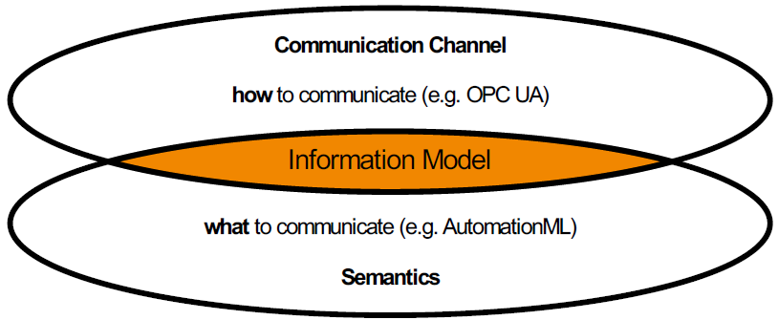
SYNTAX
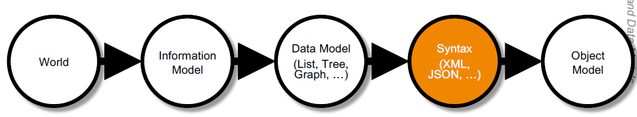
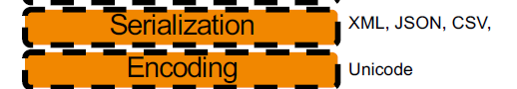
SENMANTICS
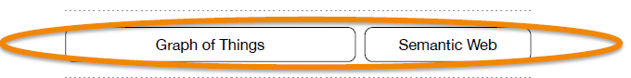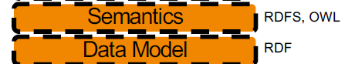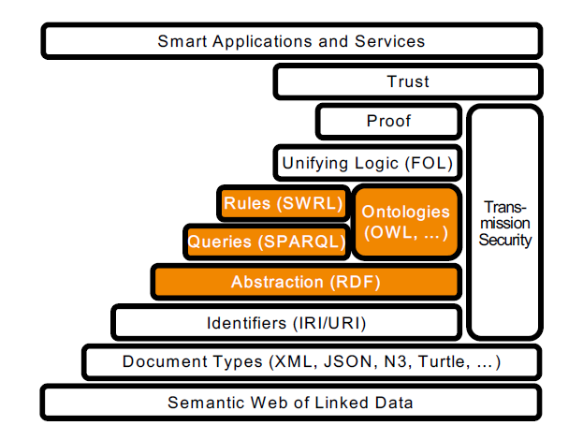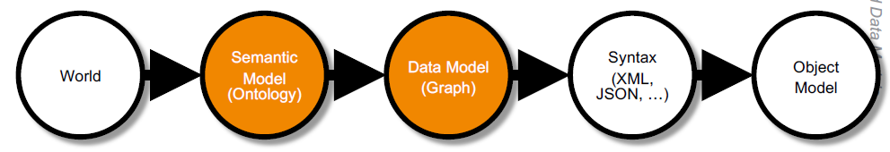
ARTIFICIAL INTELLIGENCE
- Strong AI: generic, “human-like” intelligence
- Weak AI: specific areas of application
- sub-symbolic AI (statistics) - implicit generation of knowledge through certain weightings / target metrics (e.g. reinforcement learning). Formalized domain knowledge, knowledge-based systems
- symbolic AI (logic) - explicit, formal description of knowledge. Statistical evaluations
SYNTACTICAL INTEROPERABILITY
SYTAX VS. OBJECT MODEL & DATA MODEL
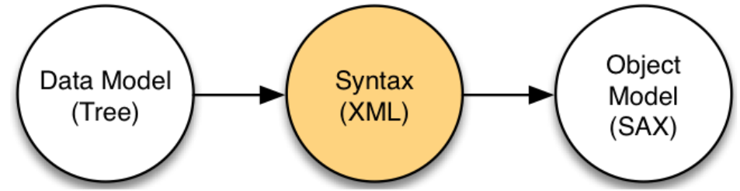
- Typical view as developer, e.g. XML Schema, XML file, SAX object
- SAX=Java API for XML
- JSON is just another serialization of a tree data model
- DOM = Document Object Model
SAME INFORMATION & DATA MODEL
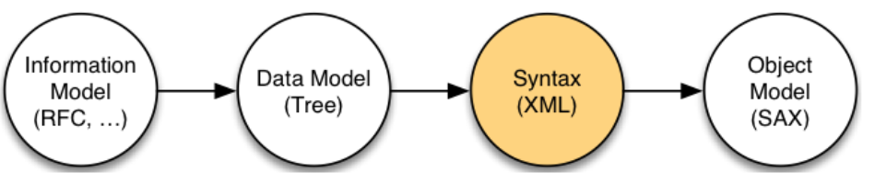
- Both might describe the same underlying information
SAME WORLD CONCEPT
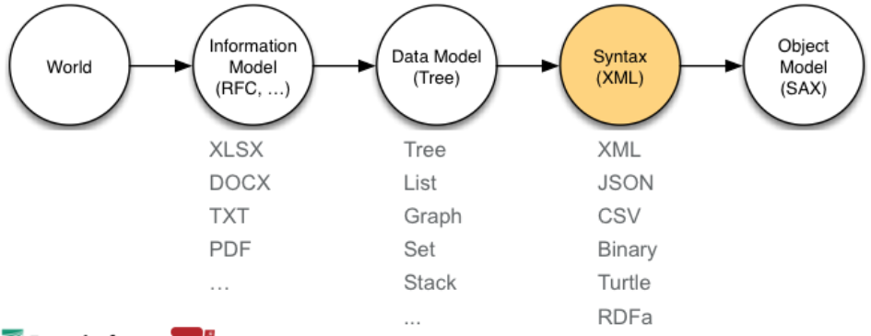
- This information model is an abstraction of a real word concept
- Usually human readable (from humans for humans)
SEMANTIC INTEROPERABILITY
IT’S ALL ABOUT SEMANTICS (=MEANING)
LEVELS OF MEANINGFULNESS
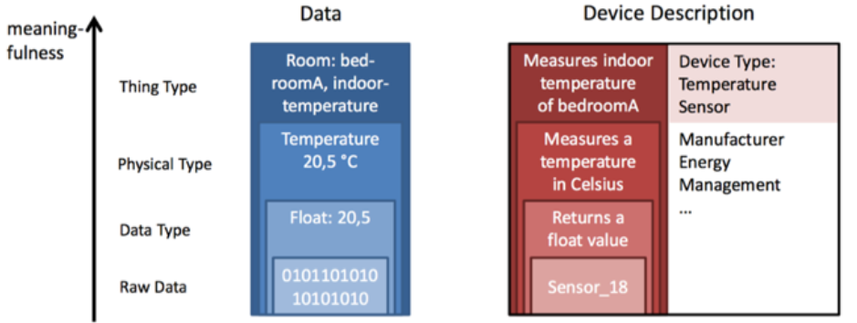
- Raw data: a list of "0" and "1
- Data type: Interpretation of the raw data. Probably content of the basic lectures.
- Physical type: Metadata on the meaning of the data
- Building on this, an ever-growing knowledge graph of metadata can be generated - room temperature in Building X in City Y with Mayor Z born in Year A, as well as writer B, the...
SEMANTIC MODEL
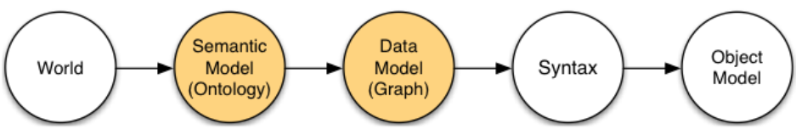
- Moving from human readable information models to formal information models
- Moving from lists or trees to graph data models
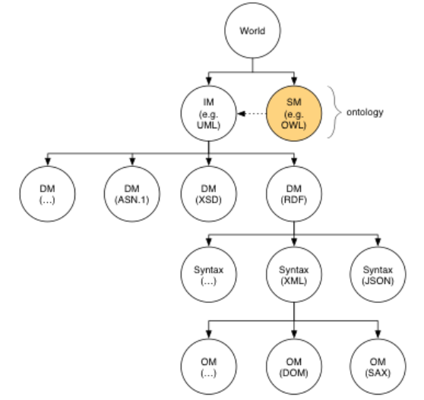
- Another view
- UML is already a formal information model
- So is the OPC UA information model
- However, with semantic information models we move towards symbolic KI capabilities
SEMANTIC INTEROPERABILITY IN DIFFERENT FIELDS OF APPLICATION
- Use of semantic information models in different fields of application
- Use of semantic information models in different products
THE SEMANTICI WEB IS ONE POSSIBLE IMPLEMENTATION
- The Semantic Web is ONE possible implementation of the related subsymbolic KI mechanisms
THE SEMANTIC WEB
TERMINOLOGY
The application of semantic web technologies for interoperable communication within the Internet of Things
GRAPH OF THINGS – USE OF THE SEMANTIC WEB WITHIN THE IOT
- The semantic web is the extension of the world wide web that enables people to share content beyond the boundaries of application and websites
- It’s origin from the web community
WHERE IS THE SEMANTIC WEB
- Annotated within HTML- RDFa serialization (RDF in attributes)
- Also modern web pages are using RDFa
- ONE possible application of Semantic Web Technologies are web pages (=largely distributed, heterogeneous, federated and linked resource database)
- NOT limited to web pages
- Needed as soon knowledge representation is directed towards machines, not humans -> IoT
CONVERTING FROM ONE SERIALIZATION TO ANOTHER
- Agnostic towards its serialization: RDFa, XML, N3, JSON, …
SEMANTIC WEB LAYER CAKE
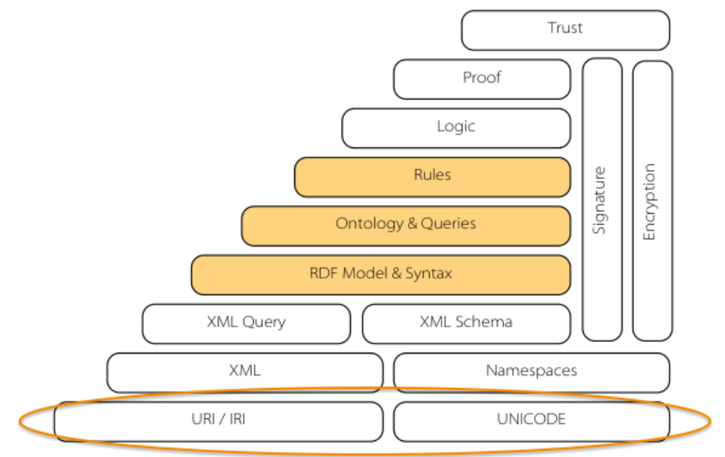
URI
- Name: Uniform Resource Identifier
- URN: Uniform Resource Name
- URL: Uniform Resource Locator
- Description: String of characters used to identify a resource
- Form: scheme: [//[user[:oassword]@host[:port][\path][?query][#fragment]]]
- Core concept is the unique identification of concepts in a largely distributed manner
IRI
- Name: Internationalized Resource Identifier
- Description: String of characters used to identify a resource using Unicode
XML QUERY AND SCHEMA
JSON SCHEMA
- Defines the syntax of a JSON document (it’s a tree structured data model)
- Example JSON:
{“name”: “George Washington”,
“birthday”: “February 22, 1732”}
- Example JSON Schema:
{“type”: “object”,
“properties”: {
“first_name”: {“type”: “string”},
“last_name”: {“type”: “string”},
“birthday”: {“type”: “string”, “format”: “data-time”}
}
}
- Basic types: string, integer, number, object, array, Boolean, null
- To be used for simple verification processes
RDF
- Name: Resource Description Framework
- Model: It’s just a labeled, directed multi-graph (not an XML tree)
- Idea: Triplets using URIs (Subject – Predicate – Object)
- Advantages: RDF is actually both, a graph data model and an initial vocabulary to define types and relationships (first simple form an ontology)
- Examples:
<urn:nasa:sensor:hubble><rdf:type>
<http://nasa.gov/resource/type/telescope>
A DIRECTED, LABELLED MULTI-GRAPH “ON TOP” OF XML, JSON, …
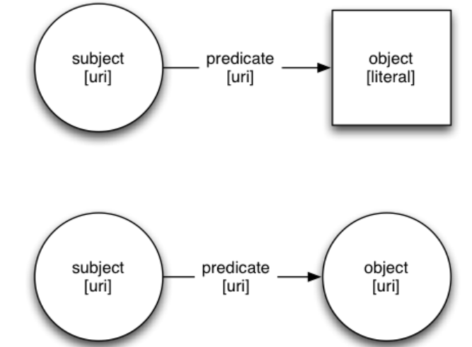

RDF IS A GRAPH DATA MODEL
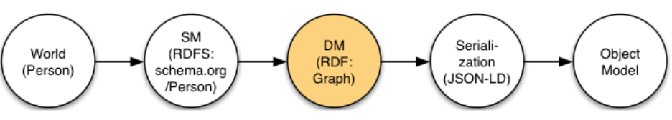
- Serialization:
- XML (application/rdf+xml)
- N3 (Notation 3)
- Turtle
- JSON-LD
- RDFa
- Disadvantage: RDF defines mainly the way how to write information and only partly of what to write
- RDF is a model, not a syntax
JSON-LD IS ONE POSSIBLE SERIALIZATION OF AN RDF GRAPH
ONTOLOGIES AND QUERIES
ONTOLOGIES - DEFINITION
- In general: the terminology and concepts are often not well used (fuzzy)
- Vocabulary: list of unambiguous, non-redundant explicit terms (maybe w/o meaning)
- Taxonomy: organized vocabulary into a (poly-)hierarchical structure
- Thesaurus: networked vocabulary using associative relationships
- Meta-model: rules on how to construct models within a domain
- Definition: An ontology
- Formally represents knowledge
- As a hierarchy of concepts
- Using a shared vocabulary
- To denote the types, properties and interrelaitonships
- Of those concepts
ONTOLOGIES – RDFS
- Ontology: Describes the semantic – the meaning of a resource
- Resource Description Framework (RDF): has already limited ontology support by providing rdf:type
- Resource Description Framework Schema (RDFS):
- Officially the “RDF Vocabulary Description Language”
- The term “Schema” is retained for historical reasons
- Defines legal uses of various classed and relationships
- Introduce for example rdfs:subClassOf or rdfs:range
AN ONTOLOGY IS A FORMALIZED INFORMATION MODEL
ONTOLOGIES – OWL
- Name: Web Ontology Language
- Idea: Very expressive knowledge representation language
- Advantages: Way higher expressivity. Adds many property characteristics (e.g. symmetry and tansitivity), mappings (e.g. owl:sameAs or owl:equivalentClass) and complex classes
- OWL is based on description logics, that are a family of logics that are decidable fragments of first-order logic
QUERIES
- Queries: Query & Update information in an RDF graph (similar to SQL)
- Types: SPARQL (SPARQL Protocol And RDF Query Language)
- More powerful than SQL (e.g. it supports the search for transitive relations in the database)
RULES
- Underlying concept is formal logic: propositional logic, predicate logic, description logic, rule-based systems, …
- Based on this formal knowledge representation we can now infer implicit knowledge using reasoning
- Rules: Simple way of encoding knowledge
- Reasoning: Automatically draw logical consequences based on rules
- It’s possible to infer knowledge that has not been described explicitly in the graph
- Inference Engine: understands the semantics and expand the number of triplets
LINDED OPEN DATA
5 STAR LINKED OPEN DATA
- Available on the web (whatever format), but with an open license (e.g. an image scan)
- Available as machine-readable structured data (e.g. excel instead of an image scan)
- As before, but using a non-proprietary format (e.g. CSV instead of excel)
- All the above, plus use open standards (RDF & Co.) to identify things, so that people could point at your stuff
- All the above, plus link your data to other people’s data to provide context
LINKED RDF
- Rules
- All kinds of conceptual things have names that start with HTTP
- Looking up these HTTP names i will get back some data in a standard format
- That information got relationships to other things that is related and starts with HTTP
- Basics
- Use URLs as names for things
- Use HTTP URLs so that people can look up those names
- Provide useful information about what a name identifies (RDF, SPARQL, etc.)
- Include links to other URLs. So that they can discover more things
LOD CLOUD REQUIREMENTS
The LOD cloud diagram shows datasets that have been published in Linked Data format. It is based on metadata collected and curated by contributors to the Data Hub
- There must be resolvable http:// (or https://) URIs
- They must resolve, with or without content negotiation, to RDF data
- The dataset must contain at least 1000 triples
- The dataset must be connected via RDF links to a dataset that is already in the diagram
- Access of the entire dataset must be possible via RDF crawling, dump or SPARQL
ONTOLOGY MAPPING PROBLEM
ISSUE: USING DIFFERENT ONTOLOGIES FOR THE SAME DOMAIN
STREAMING PROCESSING
ADDING DYNAMIC DATA TO THE LOD CLOUD
LINKED STREAM DATA
Dynamic RDF triplets are combined with queries from static triple stores to answer application specific questions

